

Project Plan

2810ICT – Software Technologies



Griffith university

trimester 2, 2022

Andrew Kinnaird (s2843939) | Shakya Fernando (s5169761)

Table of Contents

**1.0** **Introduction** 2

**1.1 Background Information** 2

**1.2 Scope** 2

**1.3 Document Contents** 3

**2.0 Work Breakdown Structure** 3

**3.0 Activity Definition and Estimation** 4

**4.0 Gantt Chart** 7

# **Introduction**

## **1.1 Background Information**

The assigned group-based project requires the completion of simple data analysis and visualisation through a graphical user interface. The subject of this task is a hand-picked dataset; Australian NSW Traffic Penalty data 2012 – 2017. The project consists of two phases: design and implementation.

The design element of this task consists of producing a project plan, which includes: a Project Overview, Work-Breakdown Structure, Activity Definition and Estimation, and a Gantt chart. The project plan will be used to define our goals and objectives by creating an overview and a work-breakdown structure, which will subsequently define our activities. A Gantt chart will be utilised for the scheduling and time estimation of tasks. A Software Design Document will be developed containing a Systems Vision Statement, a formal list of Software Requirements, Use Cases, System Components, Software Design, and an early Interface Design.

The implementation process will be determined based on the design created in the first phase. Before implementation, a testing plan will be formulated to thoroughly test various components of the system. Upon completion of testing a report will be made to process the results alongside a user manual that will explain how to use the software and show it features. To finish the implementation phase, an executive summary will be utilized to present the data over a 12-month period.

## **1.2 Scope**

The project objective is to design and implement a system that will enable users to have access to a wide range of information regarding NSW Traffic Penalty Data. The system will assist in the visualisation of data and be able to perform simple data analysis tasks. The goal is to explore and understand the insights of the overall severity of fines. This can be further expanded upon by looking at the type of fine (speeding, parking, etc.), the dates when these offences occur and the fine amount for each category of offence.

Generally, we will be able to answer questions such as:

* What type of offence are more likely to occur?
* Where are the most offences being committed (location code)?
* Is the fined amount increasing over the years?
* Are the number/rate of fines increasing? If so, what measures can the NSW government take to prevent or reduce these offences?

Additionally, the system will be able to utilise all attributes and data to output a reasonable answer and provide a visual representation of that information (where possible) with given constraints. The system should provide an insight into the Australian NSW Traffic Penalty data to determine if more action must be taken to maintain road safety.

## **1.3 Document Contents**

The document contents of this project plan will feature a system to help analyse and visualise data for fines issued in NSW Australia by exploring the selected data set. The Australian NSW Traffic Penalty data features a various type of data which will be explored and presented in a user-friendly interface. The project plan will include documents such as A Work Breakdown Structure, Activity Definition and Estimation, A System Vision Document, and A Gnatt Chart. Additionally, it will include user and software requirements, use cases, software design and user interface design. The system will design then implemented and tested for certain requirement and criteria to access its functionality and reliability.

# **2.0 Work Breakdown Structure**

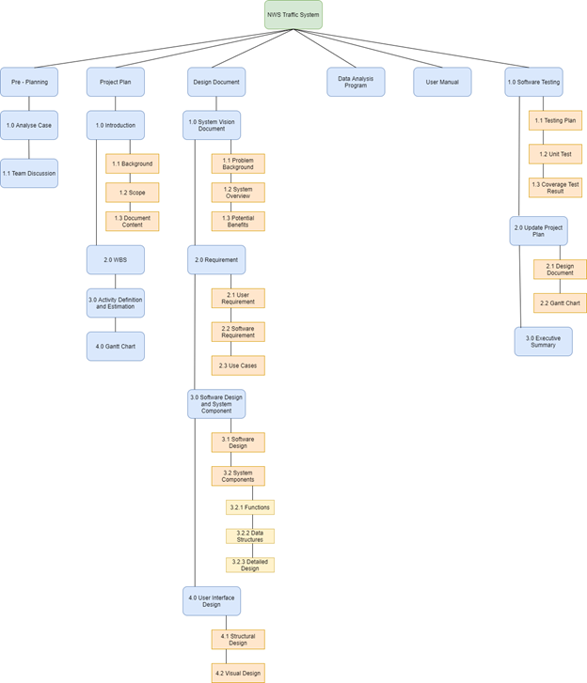

# **3.0 Updated Activity Definition and Estimation**

|  |  |
| --- | --- |
| Activities | Duration |
| **Pre - Planning** | 1 Day |
| 1.0 - **Case Analysis:** We analyse the case and determine which dataset to use for this assigned task. | 1 day  5 August 2022 |
| 1.1 - **Team Discussion:** Used to determine when each team member is free for consecutive meetings each week. | 1 day  5 August 2022 |
| **Project Plan** | 4 days |
| 2.1 - **Background:** Provide background information for the task at hand. | 1 day  6 August 2022 |
| 2.2 - **Scope:** Determine the scope of the software being created - what will be included and what will not. | 1 day  6 August 2022 |
| 2.3 - **Document Content:**  Convey what will be covered in the supplied documentation. | 1 day  6 August 2022 |
| 2.4 - **WBS:** Determine each activity needed to be undertaken to complete the project. | 1 day  7 August 2022 |
| 2.5 - **Activity Definition and Estimation:** Defining each activity found in the Work Breakdown Structure, as well as determining a time estimation for the task. | 1 day  7 August 2022 |
| 2.6 - **Gantt Chart:** Used to determine the management of time regarding the completion of project activities. | 2 days  8 - 9 August 2022 |
| **Design Document** | 18 days |
| 3.1 - **Problem Background:** Describe the problem / reasoning as to why the system is being created. | 3 days  10 - 13 August 2022 |
| 3.2 - **System Overview:** List of capabilities that the system must be able to perform upon completion. | 3 days  10 - 13 August 2022 |
| 3.3 - **Potential Benefits:** List of potential benefits the system will bring upon completion. | 3 days  10 - 13 August 2022 |
| 3.4 - **User Requirement:** Details of what a user needs to be able to do to use the completed system. | 2 days  14 - 17 August 2022 |
| **Build Design** |  |
| 4.1 - **Software Requirement:** Details of what the software needs to be capable of and the functionality that it will provide. | 2 days  18 - 20 August 2022 |
| 4.2 - **Use Cases:** Details of how users will interact with the system. | 4 days  18 - 22 August 2022 |
| 4.3 - **Software Design:** Diagram of how the system will work. | 1 day  23 August 2022 |
| 4.3.1 - **Functions:** List of all the functions that make up the system, detailing return values, inputs, side effects etc. | 2 days  24 - 25 August 2022 |
| 4.3.2 - **Data Structures:** List of all the data structures in the system, detailing type, description members etc. | 1 day  25 August 2022 |
| 4.3.3 - **Detailed Design:** writing pseudo-code that runs on the algorithms of data structures | 4 days  26 - 30 August 2022 |
| 5.0 - **User Interface Design:** Description of the tools and insights used in the creation of the user interface design. | 2 days  31 August - 2 September 2022 |
| 5.1 - **Structural Design:** Navigational and informational structure of the system, presented with a diagram and discussion. | 5 days  31 August - 5 September 2022 |
| 5.2 - **Visual Design:** All the visual elements of the system, presented with wireframes, icons, layout etc. Supported with discussion. | 5 days  31 August - 5 September 2022 |
| 6.0 – **User Manual:** Creating user manual and description of what the program does. | 4 days  5 – 9 September 2022 |
| 6.1 – **Testing:** This includes Testing plan, unit test, coverage report, and requirement acceptance testing. | 12 day  9 – 23 September 2022 |
| 6.3 – **Updating:** update project plan, design document and Gnatt chart | 3 days  23 – 26 September  2022 |
| 6.4 – **Executive Summary:** Summarize the finding and describe what the program analysis | 3 days  26 – 29 September  2022 |

# **4.0 Updated Gantt Chart**

